University of Wollongong
MGNT110: Introduction to Management
MGNT208: Introduction to Management for Professionals
ASSESSMENT COVER SHEET
Student name: Joseph Koh
Student number: 1441309
Tutorial day/time:
Tutor name: Ms. Jesslyn Lau
Assessment number: Assessment 2, Part B, Reflection
STUDENT DECLARATION
I declare that this assessment is entirely my own work and has not been submitted for assessment in any other subject or course. This work complies with the University of Wollongong's Academic Integrity Policy.
Signature: Joseph Koh
Date:

Description (What happened?)
- Explain how your group was formed
- Describe the team’s overall goals and what you aimed to achieve
- Outline your contributions in:
  - Communication within the team
  - Task delegation
  - Meeting deadlines
  - Conflict resolution
  - Applying management theories
  - Preparing and delivering the group presentation
Feelings (What were you thinking and feeling?)
- Describe your initial reactions to the group task
- Explain how you felt about:
  - Working with others
  - Presenting as part of a team
- Show how your feelings changed over time
- Link these changes to any issues or developments within the group
Evaluation (What worked well or didn’t?)
- Assess your personal effectiveness in:
  - Collaborating with teammates
  - Communicating your ideas
  - Managing your assigned role(s)
- Identify your strengths
- Identify areas where you struggled

Analysis (Why did things happen that way?)
- Select ONE specific challenge, conflict, or success from your experience
- Apply ONE relevant management theory (choose from):
  - Team management (Week 3)
  - Motivation (Week 3)
  - Leadership (Week 4)
  - Conflict (Week 5)
  - Power and politics (Week 6)
- Analyse the situation using the chosen theory
- Explain your role in influencing the team’s outcome
Conclusion (What did you learn?)
- Summarise key takeaways
- Reflect on what you learned about yourself
- State what you would do differently in future
Action Plan (What will you do in future?)
- Outline specific steps to improve based on your analysis
- Ensure steps are:
  - Clear
  - Realistic
  - Achievable
- Link your plan to the chosen theory
- Present your plan using SMART goals (Specific, Measurable, Achievable, Relevant, Time-bound)

Description
Our team culture was officially established when we created our Team Expectations Document. We aimed for a high distinction and set clear guidelines to follow throughout the assignment. (see Appendix A). Setting expectations at the start of the team formation created a psychological contract which fostered a sense of responsibility and accountability among ourselves.
Feelings
Evaluation
Analysis
Conclusion
Action Plan

Appendices
Appendix A: Team Expectations Document
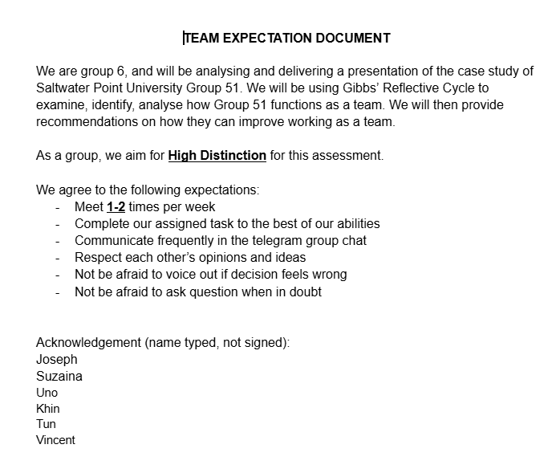

Appendix B: Section Allocation
